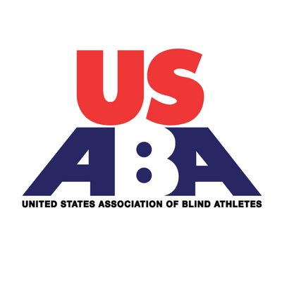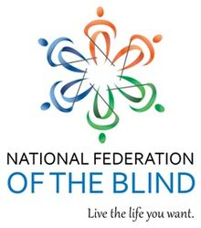

Missouri Blind Sports Day

**Sunday, May 5, 2019**

**Time: 7:45 AM- 12:30 PM**

**Location: Missouri School for the Blind**

7:45 Registration/Check-in

8:00 Session 1: Goal ball and Soccer Skills

9:30 Session 2: Judo

10:45 Session 3: Running/Walking with Achilles Guides

12:00 Picnic in Tower Grove Park. Bring your own picnic lunch

For more information, contact Robin House at 314-265-6852 Robin@mindsrealm

Visit [www.nfbmo.org](http://www.nfbmo.org)

For more information and to register for this FREE community event