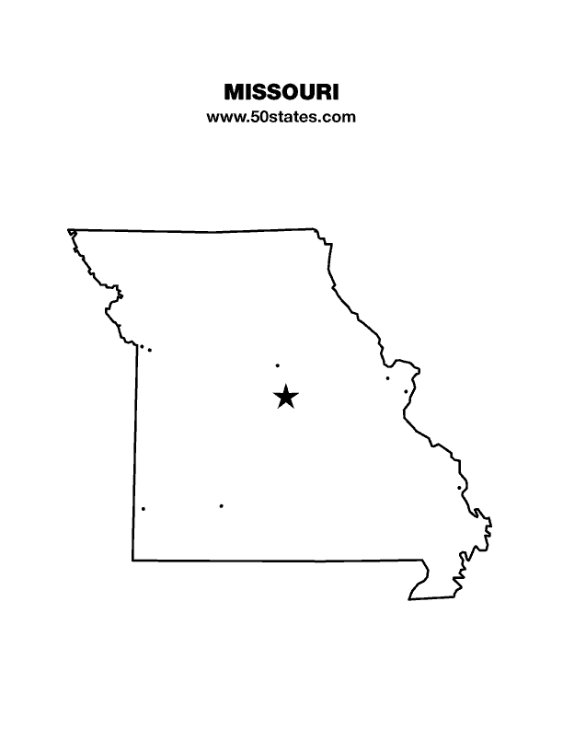
The Blind Missourian
September 2019

Table of Contents

I Love Braille by Jenny Carmack 1

What Happened in Vegas: Reflections on My First National Convention by Daniel Garcia 3

Fun on the River by Carol Coulter 5

Chris Griggs by Rita Lynch 8

Our Federation Friend, LaVern Toebben by Rita Lynch 9

Our Last Visit with Bob by Rita Lynch 11

One Minute Message

The National Federation of the Blind knows that blindness is not the characteristic that defines you or your future. Every day we raise the expectations of blind people, because low expectations create obstacles between blind people and our dreams. You can live the life you want; blindness is not what holds you back.

Pledge of the
National Federation of the Blind

I pledge to participate actively in the efforts of the National Federation of the Blind to achieve equality, opportunity, and security for the blind; to support the policies and programs of the Federation; and to abide by its Constitution.
I Love Braille
By Jenny Carmack

“I love braille,” said Salome Cummins several times throughout the two weeks of the 2019 Missouri Braille Enrichment for Literacy and Learning (BELL) Academy.
Yes, the Missouri affiliate had our 6th successful BELL Academy. The staff and bell ringers made some new memories and had a lot of fun working together. As another bell ringer said, “I liked everything at BELL.” (Russell Dorn)
This year we brought back some of the familiar favorite activities. The bell ringers enjoyed running on the Ninja Running Line in which they were timed and tried to run faster and faster to beat their own best times. We also got a good laugh out of writing silly stories by passing a braille writer around and adding a sentence to the story without reading what was already written. One of those stories consisted of someone turning cart wheels in the frozen food section of the grocery store. The bell ringers had the opportunity to become pirates for a while, using their fingers to dig for hidden treasures. They sure did a great job digging up bells, beads, and stones ARRRR! We eagerly worked on our slates each day and became more proficient at loading the paper, using correct spacing, and improving accuracy. Using the tennis balls and muffin tins was a fun way to show off our knowledge of Braille signs and contractions. How quickly do you think you could form every letter in the alphabet with the muffin tins and balls? Some of our bell ringers are quite fast!
In addition to our familiar favorites, we also had some new activities that just may make the favorites list in the future. CRASH, was the sound the Jenga blocks made when the tower fell over. We played Jenga several times, and everyone used steady hands when removing a block and placing it on the top of the tower, but we all exploded with laughter when the tower would come toppling over. During a game of Braille Memory, we had to put on our thinking caps to try and remember where we last saw a particular card. “Where is that …” could be heard as each Memory game player took their turn. Mr. Shamar, a volunteer from the community, came one day to paint with us. We got to paint on different textures and create a painting on plastic face molds. That was a fun, but messy activity. In another new activity we worked on naming a variety of feelings and what makes us feel that way. “I feel sad when I am not with my mom,” “I feel mad when I make a mistake,” “I feel tired when I play a lot,” or “I feel hungry when it is almost lunch time.” Those were some of the emotions discussed during this activity, as well as some strategies for getting through some hard feelings like anger or sadness. We learned that we can squeeze clay or rub a smooth stone to work through negative feelings.
Of course, every year we celebrate Louis Braille, but this year’s celebration was different in that it was a carnival. Just like at any other carnival, we had a variety of games to choose from and we won prizes. There was face painting, hula hooping, fishing, and diving for creatures in the lagoon. (What was that creature? Don’t worry, you can find out by turning it over and reading its name which was written in braille!) A field trip is always an adventure at the BELL Academy, and this year was no exception. We went to a new place called “We Rock the Spectrum.” The bell ringers jumped on trampolines, swung on different types of swings, climbed the rope wall, zoomed across the zip line, and more at this safe and fully inclusive activity gym. Last, but not least, the BELL Academy would not be complete without a parent presentation. However, there was a new twist on this year’s presentation. We put on the play of “The Three Little Pigs.” All of the staff and bell ringers worked hard all week to learn the play and everyone really enjoyed it. In fact, the BELL staff has been given an assignment for next year; we are to find or write a play that is about Louis Braille. (Good Luck!)
Obviously, every activity that we do throughout the two weeks cannot be listed here or it would be a book. However, these were some of the highlights from the BELL Academy. All of the activities include skill building in one or more areas. Some of the skills we address in these activities include tactile skills, spatial awareness, Braille, orientation and mobility, relationship building, and others. We strive to plan activities which will help our bell ringers to learn while they are having fun. I would like to take this time to thank individual donors, members, and chapters who made monetary or in-kind donations to the BELL Academy; these donations provide the support we need to have a strong program for the bell ringers. A big thanks also goes out to the volunteers who worked very hard and gave up their time this summer to make the BELL Academy successful. It takes a lot of dedication and diligence from those who volunteer to be present each day of the two-week academy, but also to help in the planning and preparation that takes place prior to the BELL Academy. I would also like to thank the parents of the bell ringers for their dedication in getting their child to BELL each morning. Most of the parents have to make changes to their family’s daily routine to make sure their child can participate each day. That is truly worth a huge thanks. Without parents, volunteers, and donations we would have no BELL Academy, so thank you, one more time!

What Happened in Vegas: Reflections on My First National Convention
By Daniel Garcia

The cliché about what happens in Vegas stays in Vegas ought not apply to the national convention of the National Federation of the Blind. The energy, enthusiasm, and love we felt should be shared with all Federationists across the country. During the Rookie Roundup the First Lady of the Federation, Melissa Riccobono, said that national conventions are like a shot in the arm providing us with more fuel to continue the work of the National Federation of the Blind. This first national convention did indeed have that effect on me, and I want to briefly recount what happened in Vegas the week of July 6 to July 13, 2019.
When we arrived in Las Vegas on Saturday, July 6, my roommate Jeff Giffen and I decided that we would walk around the hotel to get acquainted with what would be our home for one week. On Sunday I attended various meetings and seminars. Early in the morning I went to a JAWS users’ group where I learned about some new features in JAWS. I then walked over to the Crafter’s Marketplace sponsored by the NFB Crafters Division where I purchased convention souvenirs hand-made by blind people. In the afternoon I took a yoga for beginners class and then stayed for the One Touch Self Defense Seminar; both of these events were sponsored by the national Sports & Recreation Division. After a quick dinner I went to the Exhibitor’s Showcase to get a preview of what the vendors would have available to demonstrate and sell during the week at the Exhibit Hall. Last on the agenda for Sunday night was the Rookie Roundup, where we got to meet many new first-time convention attendees. Many federation leaders including President Riccobono welcomed us to our first convention, shared their experiences of their first time attending an NFB convention, and gave us a preview of what was to come later in the week.
On Monday morning Jeff and I walked the exhibit hall, where we purchased various items. In the afternoon, I attended the Resolutions Committee meeting so that I would have a better understanding of the resolutions we would be voting on later in the week. On Tuesday morning we witnessed the presentation of various awards at the board meeting, and we learned that the 2020 convention would be in Houston, Texas, from June 30 to July 5.
Wednesday’s General Session featured the roll call of states and the annual presidential report. In his report, President Riccobono said that though we as blind people are making much progress, we still have much more work to do to attain the freedom we desire. Later that evening I attended a meeting of the Communications Committee. In this meeting various presenters covered such topics as outreach to Spanish-speakers, communicating with the deafblind, and ensuring that social media posts make generous use of pictures which, of course, ought to be described for the benefit of people who use screen readers. The democratic character of the National Federation of the Blind was on display during the Thursday General Session. During the morning session we had elections during which several board members were reelected to the board and a new board member, Nevada Affiliate President Terri Rupp was elected to her first term on the board. In the afternoon session, we voted on twenty-one resolutions which outline the policy priorities of the National Federation of the Blind. In the evening I attended two meetings, the first being a demonstration of the Microsoft Soundscape Application. This application can be used as a tool to find out what stores, restaurants, and other businesses are nearby, as well as to set up beacons to find particular places. I then went to the Brand Ambassador’s meeting, where I learned how to more effectively represent our NFB brand to the public and potential new members.
During the lunch break on Friday, I went to a meeting of the Committee on Autonomous Vehicles and Innovations in Transportation. Much work is underway by various automobile manufacturers to bring the autonomous vehicle to the market. One key point that I took away from that meeting was that blind people in all fifty states need to take a leading role to ensure that states craft policies and laws that do not discriminate against the blind operating autonomous vehicles. At the local level blind people should be working with elected officials to bring about the smart city of the future. Once the afternoon session was over on Friday, we were directed to immediately get up out of our seats, turn around, and find the nearest exit. In a mere two hours, the banquet would be held in the same room and the hotel staff needed as much time as possible to set up the tables. At about 6 pm, Jeff and I made our way back to the area where the banquet was to take place. I would describe our effort to find our table as an exercise in organized chaos. There were nearly 3,000 people in a small area trying to get into the banquet hall. It was so crowded that it was difficult to walk, but thanks to the efforts of the ushers, we went to the right entrance and were guided to the right table. President Riccobono’s 2019 banquet speech was titled “Choice, Exploration, and Resistance: The Road to Freedom for the Blind.” In his speech President Riccobono stated that compared to 1940 when the NFB was founded, blind people have more choices and more freedom; but compared to where we want to be, our choices are still not adequate. He urged all of us as blind people to make choices that align with the freedom that we seek.
Overall my first convention experience exceeded my expectations. I now have a better understanding of the NFB. This convention not only challenged my orientation and mobility skills, but it also challenged me to expect more out of my life, and to work harder and smarter to build the Federation. I would be remiss if I did not express my gratitude to the Kenneth Jernigan Fund Committee and to the NFB of Missouri for providing me with the funds necessary to attend my first national convention. I am making plans to go to our next national convention in Houston next year, and I hope that many blind Missourians do likewise.

Fun on the River
By Carol Coulter

On August 16, 2019 twenty-one members of the National Federation of the Blind met at the NRO Campground near Lebanon, Missouri. We had members from across the state representing five chapters and even two states; Alice Hebert from Louisiana joined us again this year. We also had people ranging in age from a sixth grader to retirees; as you can see this trip was for everyone.
This was Elisabeth and my first year to go, and we had a great time after our adventure in getting there; GPS’s aren’t always to be trusted. After picking up Stephanie Contreras in Jefferson City and heading further south, our trusty GPS decided to lead us down some roads that as I told everyone, “you wouldn’t want to drive your tractor on.” We also encountered a road that was covered with water and had to turn the van around on this narrow dirt road in the dark. Praise to Elisabeth for her excellent driving on these terrible roads and her ability to get us out of the predicament we found ourselves in. By the way, everyone else found their way there just fine.
After arriving at the campground at about 10:30, about two hours later than hoped, we entered a very nice cabin. It had a full kitchen, two baths, window air conditioner, and eight double beds - plenty of room. After some socializing and story-telling we headed for bed to rest up for our float trip in the morning which would start with a bus picking us up at 9:30 A.M.
Since I am not a swimmer and was hesitant about going, I am going to try and be a little more specific in my description with the hopes that it will help dispel any fears that others might have and convince you to come join in on the fun next year.
Saturday morning everyone came to the larger cabin to get ready for our day. We made our lunches, put on sunscreen and bug repellent. We then took the coolers with our lunches and water and loaded the bus which took us down to the river. We had discussed who was in each raft before loading the bus, so we knew which raft to go to when we got there. As we got off the bus, they handed everyone a life jacket. It was up to you if you wore it, but state law requires that they provide one for everyone on a water craft. To help some of you visualize, the raft was sort of like those you see in plane or boat rescues or comedies where someone pulls a cord and it inflates in a small space. We averaged five people to a six-person raft and, Bill Wilson was in a canoe so he could help anyone who might need a little assistance. The sky was overcast and kept the sun from beating down on us so that was nice. The river was nice and calm and would be a little faster in some places. I would say that ninety percent of the time an adult could stand up in the water, and it would not be above waist to chest high. I thought it was fun to try and maneuver around the obstacles in the water, for example, tree branches, a rock, other rafters, and sometimes the water wasn’t deep enough so you would get stuck. I lost an oar in some brush; it got stuck and the current was just fast enough that it pulled it out of my hand. Lesson learned: hold on tight to your oar.
We found a place to pull the rafts out of the water and break for lunch. We passed out the lunch bags and drinks, and then after the trash was put in the trash bags that were provided, some people played in the cold water before we headed back down the river to finish our seven-mile float in our rafts. If you made it to the seven mile pull out spot by two o’clock, you could continue for another seven miles. Only one of our rafts decided to take this challenge; the rest of us boarded the buses and headed back to the cabins.
As we waited for our last group to return, some of us played cards while others socialized or took a nap. I should add that we had a fourteen-person cabin and a four-person cabin and seven members decided to tent camp. The tent campers cooked their supper over the fire, while the rest of us went to a little bar and grill about seven miles down the road for supper. It was actually very good. After returning from supper, those who wanted to joined the campers around the campfire for some more good conversation and laughs.
Check out time was 11:00 a.m., so Sunday morning we were up early cleaning up and packing up our stuff to head our separate ways after a fun filled weekend.
I hope this helps some people make a decision about coming next year. As you can see, we had cabins or tents, we had old and young, and people who could swim and others like myself who couldn’t swim. We had two people who came down Saturday just to raft, but not spend the night. We even had one who chose not to raft but came for the camaraderie.
Randy said that if he had known there was a full kitchen, he would have made us all dinner like spaghetti or something. Let me tell you that would have been worth coming back for. There is something for everyone, so please stay tuned for information on the next trip and plan to come join in on the fun.

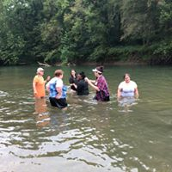 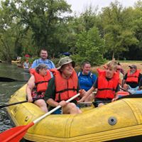 People playing around in the river.
Ben and Melissa K., Brent, Cari and Ben C. rafting down the river.
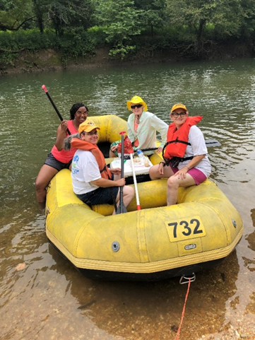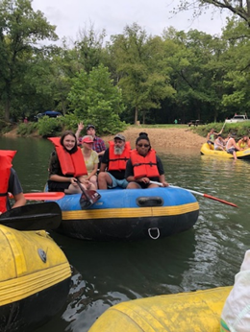
Alice, Samantha, Carol and Elisabeth
in their raft.
Amy, Jenny, Chris, Amiah and Amber Lynn in their raft floating down the river.
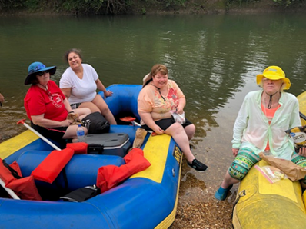 Shelia, Stephanie, and Kathy in their raft and Alice
sitting across in her raft.

Chris Griggs
By Rita Lynch

Our chapter treasurer, Chris Griggs, had been living on the outskirts of Jefferson City, but decided to sell his home and move in town as transportation was a real problem. Chris bought an older home in the Old Munichburg area which he knew would require lots of remodeling. He moved in September 28, 2018 and got to work. Now, less than a year later, he is the proud recipient of not one, but two special awards as a result of all the hard work he has done to make his home one to be proud of. Chris was the first person to receive the Southside Pride Award, which is a new award given out by the Old Munichburg Association to individuals or businesses who do little things to show pride in the neighborhood by enhancing its historic beauty. The winner receives a yard sign in the form of a dachshund that says “Southside Pride” and $25 in Munichburg Bucks which can be used at any participating southside business. Chris was surprised with this award during The Golden Hammer Ceremony which Chris also won. The Golden Hammer award is given for larger renovation jobs and is given by the Historic Society of Jefferson City.
Chris was very fortunate that the May 22nd tornado missed his home. It came through real close, just one block from his home.
Chris also shared with us at our July chapter meeting that he has just received his LLC and is now licensed as a Segway businessman. We are all very proud of Chris and do wish him all the best in all his endeavors.

Our Federation Friend, LaVern Toebben
By Rita Lynch

It is with a heavy heart that I reflect on our friend LaVern Toebben and the blessings we received by knowing and working with her for many years. LaVern breathed her last on Wednesday August 14th at 2:55 p.m. We here in Jefferson City knew that her time here on earth was short, but we all know that this type of separation is impossible for one to truly prepare for. There are lots of Federation members around the state who knew and loved LaVern and Alvin, but for those who did not know LaVern as well, I want to share some of who she really was and why she will be truly missed.
LaVern was eighty-four years old, but her last ten years were very challenging for her and her family as she was battling Dementia and other life-threatening medical conditions. I first met LaVern in February of 1982 when she and I joined the Federation. We realized that we had so many things in common. Both of us being blind, we were wives and mothers with promises of becoming grandmothers. We were proud to be strong cradle Catholics of German ancestry. Like myself, she came from a big family and grew up out on a farm. I had learned that LaVern and her late husband George had been blessed with four beautiful daughters, Janet, Susie, Maryann and Donna. I also learned that LaVern had lost her husband, George Luecke quite unexpectedly due to a sudden heart attack in February of 1980. One month before this, her best friend, Genrose Toebben, Alvin’s first wife, was killed in an auto accident near their home. He and his wife had a beautiful family as well, four daughters, Arlene, Ruth, Patty, and Phyllis and one son, Don. It just so happened that the two families had been good friends, and all lived in the St. Martins area. Well, as it was meant to be, Alvin and LaVern were married two and a half years later, September 11, 1982, and the two families then became one big family. Alvin and LaVern were married almost thirty-seven years. I was very pleased to attend their wedding. LaVern lived the life she wanted. She was a wonderful homemaker and cook. Many of you will remember her baked goods were outstanding. She and Alvin always had a huge garden, so there was always lots of canning and preserving of foods to do. She did child care in her home for dozens of her grandchildren and other relatives and friends in her area. Both Alvin and LaVern were always very willing to help in whatever way they could for the Federation, their church, community organizations, and for whoever needed a helping hand. They experienced much tragedy throughout their married life. Amongst these tragedies were the loss of their daughter Donna just three days before Christmas in 1990 due to a drunk driver and again just a few years ago when they lost a granddaughter, Kelsie, and her fiancé on that same Highway 50 in a head on collision. Despite all this, their faith carried them through all the difficult times.
Up until the time that LaVern’s medical problems prevented them from fully participating in the Federation, they had been very active. We could count on them to bring a couple dozen of their relatives and friends to the walk-a-thon each year, which made these events very successful. LaVern went with me to lots of school and community presentations on blindness. She served many years in various positions on our chapter board including vice president, secretary and board member. Alvin also served as chapter treasurer for over ten years and chapter board member many years as well. Even though they were not able to participate in all activities more recently, they were certainly still a big part of our chapter and true Federationists. Our organization benefited greatly from their dedicated service.
LaVern’s obituary indicated that even though she was blind, she helped Alvin raise a large family and perfected her chocolate chip cookies. I want you to know, and as God is my witness, I gave LaVern that chocolate chip cookie recipe soon after we had become friends. Sometime after that, LaVern mentioned to me that her family really liked her chocolate chip cookies. I said to her that I knew that was a good recipe and was glad to have shared it with her. Then LaVern very humbly said to me, “But, Rita, I made some changes to the recipe.” At that time, I felt a bit offended. I did not understand how she could possibly improve that best ever chocolate chip cookie recipe. But I knew LaVern did not lie, so I had to accept the fact that she perfected my recipe and, I did eventually get over it.
Now that the visitation and funeral mass is over and LaVern has been laid to rest, I just want to share a couple other things that truly touched me. At the visitation, in talking with Alvin’s youngest daughter Phyllis, she shared with me that when LaVern was taken from her home for the last time, Alvin reached out and touched his wife’s shoulder and said to her, “LaVern, I’ll be there with you soon,” but we hope he will be with us for a long time yet.
LaVern and I talked many hours by phone, and she had told me a long time ago that when it would be her and Alvin’s time to be laid to rest, she would be buried between her first husband, George, and Alvin and Alvin would be buried between his first wife, Genrose and LaVern. Now I’m not the only one who was touched by this coincidence because the mortician mentioned at the cemetery that he has buried thousands of people, but this was a first for him to see this occurrence.
I am so glad that several Federationists, including Gary Wunder, Nellene Martin, Carol Coulter, Elisabeth Coulter, Phyllis Wilson, Linda DeWeese and I were able to go and pay our respects and express our sympathy to Alvin and all the family members. I know it meant a lot to them. We take comfort in knowing that she is at peace and rejoicing with her loved ones who preceded her to her heavenly home. We want Alvin to know that although LaVern is no longer with us, we want him to continue to be a part of our Federation family for many years; and LaVern, we hope to see you when we leave this earthly life to join you on that Golden Shore.

Our Last Visit with Bob
by Rita Lynch

I know we all were shocked to hear of the recent passing of Bob Watson, our friend and dedicated reporter whom we were privileged to work with at the Jefferson City News Tribune. Bob died unexpectedly on August 4th here at St. Mary’s Health Center after a brief illness. Gary Wunder and I were able to attend the visitation on August 8th at the Presbyterian Church where Bob had been a member for many years. As expected, there was a huge crowd which included lots of legislators and many of Bob’s coworkers and friends. He is survived by his mother, a son, a daughter, his sister, and his very special friend of over forty years and other relatives. For Bob’s loved ones we left a letter of appreciation and a copy of the resolution we passed at this year’s state convention commending Bob for the excellent work he has done for us for the past thirty years. Little did we know that our time was very limited to recognize him for all the work he has done for us. Thanks to Daniel Garcia for writing up the resolution and getting it to the committee.
In the News Room Bob was known as “the Bull Dog” because he insisted on reporting the whole story and as even handed as humanly possible. He was committed to reporting the news received in the words of his sources; no paraphrasing from this reporter. Bob started his journalism career here in Jefferson City in 1972 with KLIK Radio. He then moved to television with KRCG here in the local area. In 1989 Bob started working at the News Tribune and became the type of reporter we all truly appreciate working with as he reported without fear or favor. He has been the recipient of numerous awards for his outstanding work in Journalism. Bob has also been very active in his church and in his local community as well. Bob always had time to stop and visit wherever we happened to meet. We’ll truly miss Bob as we carry on the work of the Federation.

Here is the letter we sent to Bob’s family along with the resolution:

August 8, 2019

To the family and friends of Bob Watson:

As you may already know, the National Federation of the Blind of Missouri and its Jefferson City chapter think very highly of Bob Watson and the help that he gave to us as we tried to make a difference in the lives of blind people. He covered our legislative efforts every year, but even on a rainy day he joined us at a Walk-a-thon to talk more broadly about the issues that brought us together. He was a first-rate journalist who always treated us with tremendous respect, even though we did not represent a large readership or any significant cash to the newspaper. He was an affirming presence, not only because he could provide us with valuable exposure to the community but because he made it clear that he felt it an honor to be among us, to help us articulate the challenges we faced, and to spell out in detail the hopes and dreams that we hoped our organization would make real for the people we serve.
I read in Bob’s obituary his reverence for the golden rule. If ever there has been a prescription for guidance about how to behave, this precept is it, and for those of us who voted and passed the enclosed resolution, Bob was the living embodiment of it.
Through this letter and the enclosed resolution, please know how much we appreciate Bob’s touching our lives and for allowing him to touch ours. At the moment we feel sadness, but in the measure of time that sadness will give way to the joy we had in knowing him and calling him our beloved friend.
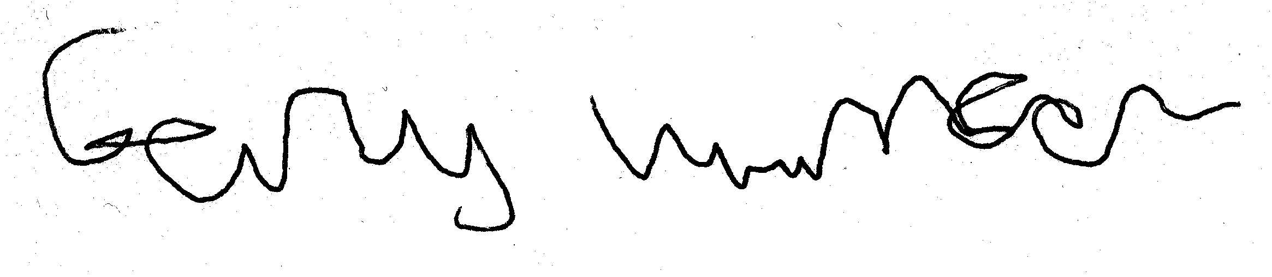
Gary Wunder

Board of Directors
National Federation of the Blind of Missouri

Officers:
Shelia Wright, President Melissa Kane, First Vice President
Jenny Carmack, Second Vice President Becky Boyer, Recording Secretary
Daniel Garcia, Corresponding Secretary Carol Coulter, Treasurer

Board Members:
Eugene Coulter Roger Crome Robin House
Amy Wilson Chris Tisdal Dacia Cole
Jeff Giffen President Emeritus, Gary Wunder

Chapter Presidents
Columbia Chapter, Eugene Coulter, 573-474-3226
Old Drum Chapter, Amy Wilson, 660-441-1907
Jefferson City Chapter, Melissa Kane, 573-473-8584
Springfield Chapter, Ben Vercellone, 417-755-5285
Kansas City Chapter, Daniel Garcia, 816-505-5520
Lewis and Clark Chapter, Chris Tisdal, 314-440-1684
Mineral Area Chapter, Roger Crome, 573-701-8409
Show-Me State Chapter, Dan Keller, 417-667-6208

Blind Missourian Editor Carol Coulter
Proof Readers Helen Stevens, Shelia Wright, and Gary Wunder
Read by Elisabeth Coulter

FREE MATTER FOR THE

BLIND AND PHYSICALLY

HANDICAPPED

NFB of Missouri
1504 Furlong Dr.
Columbia, MO 65202

