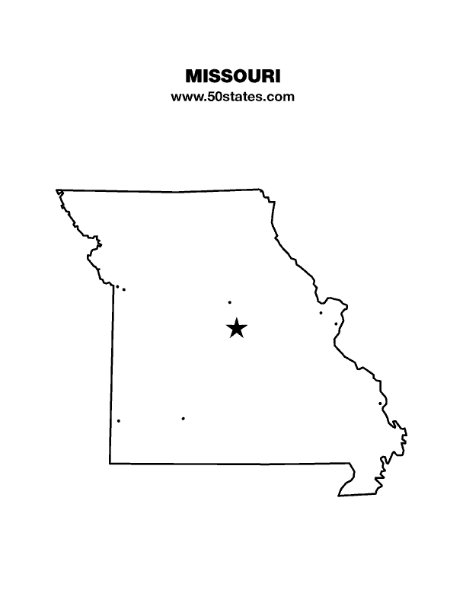
The Blind Missourian
September 2022

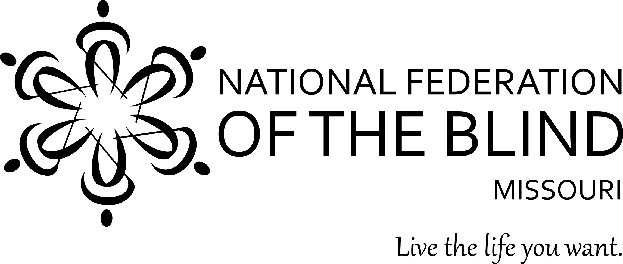

Table of Contents

Governor Parson Signs Legislation That Will Improve
Education for Blind Students 1

2023 Scholarship Program 2

How the National Braille Challenge Works
By Salome Cummins 3

Finding My Place in the NFB: My First National
Convention Experience by Alyssa Henson 5

BELL Academy: Back in Person by: Jenny Carmack 6

My Time at BELL Academy by Salome Cummins 8

Legislative Update by Dennis Miller 9

Very Important Voting Information by Eugene Coulter 11

The Missouri Association of Guide Dog Users
by Alyssa Henson 12

NFB Pledge 14

One Minute Message 14

For Immediate Release:

Governor Parson Signs Legislation That Will Improve Education for Blind Students
Blind Missourians Praise the Passage of the BRITE Act

Kansas City, Missouri (August 8, 2022): Governor Parson recently signed into law SB681 which modifies provisions relating to elementary and secondary education. Included in this legislation is the BRITE (Blind Students' Rights to Independence, Training, and Education) ACT which was originally introduced by Representative Brenda Shields as HB2150. The BRITE Act consolidates and clarifies the obligations of elementary and secondary schools in Missouri to provide instruction and services to each blind student and makes it clear that none of these services may be denied to a legally blind student simply because they may have some remaining vision.

“In April of 2021, we convened a work group that was made up of stakeholders to address concerns that had been raised, strengthen the bill text, and garner support for the BRITE Act to be introduced in 2022 by Representative Brenda Shields,” said Shelia Wright, President of the National Federation of the Blind of Missouri. “We are excited that this collaborative effort with educators led to the passage of this law which will improve the quality of education for blind Missouri students. We know that given the proper training, blind people can compete in terms of equality with sighted people in today’s labor market. This law ensures that blind Missouri students will have the tools they need to obtain employment and live rewarding and productive lives.”

###

About the National Federation of the Blind

The National Federation of the Blind (NFB), headquartered in Baltimore, is the oldest and largest nationwide organization of blind Americans. Founded in 1940, the NFB consists of affiliates, chapters, and divisions in the fifty states, Washington DC, and Puerto Rico. The NFB defends the rights of blind people of all ages and provides information and support to families with blind children, older Americans who are losing vision, and more. We believe in the hopes and dreams of blind people and work together to transform them into reality. Learn more about our many programs and initiatives at www.nfb.org.

CONTACT:
Daniel Garcia, Public Relations Chair
National Federation of the Blind of Missouri
(816) 621-0902
dgarcia@nfbmo.org

National Federation of the Blind of Missouri
2023 Scholarship Program

The National Federation of the Blind of Missouri announces our 2023 Scholarship Program. We will be accepting applications until February 1, 2023. We invite all qualified candidates to apply. Applicants must be legally blind and plan to enroll in a post-secondary institution for the fall of 2023. Applicants should live in Missouri but need not be a member of the National Federation of the Blind. Scholarships begin at $750 and are based on merit. We invite applicants to submit all information and documents online. All application materials must be received by February 1, 2023, either through the online form found at www.nfbmo.org or at the email address provided below. Acknowledgment of applications and documents will be sent upon receipt. If you have questions or concerns, please do not hesitate to contact the Scholarship Chair.

A complete application consists of the official application form and a student essay, plus these supporting documents: student transcripts, two letters of recommendation, a letter from an NFB of Missouri Scholarship Committee member, and proof of legal blindness. Please note that letters of recommendation must not be submitted by the applicant but must come directly from the person authoring the recommendation.

In an effective essay the applicant may consider sharing about his or her life in a way that gives the committee insight into him or her. The essay should cover the ways in which one lives successfully as a blind person and describe personal goals for the future. Committee members give the essay a great deal of attention.

In addition to receiving the monetary award, the scholarship finalist will attend the convention of the National Federation of the Blind of Missouri, April 14-16, 2023, at the Hilton Airport Hotel in St. Louis, MO. Hotel accommodations, convention registration, and planned meals during the convention will be included. We are also happy to help coordinate transportation to ensure this is not a barrier to our scholarship class. The type of transportation assistance may vary based on where in Missouri the winner resides and the available transportation resources in that community.

Throughout the convention, scholarship winners will have an opportunity to learn about the National Federation of the Blind and network with successful blind people. In addition, final interviews with the Scholarship Committee will aid the committee in determining the scholarship each winner will receive.

You should know that merit scholarships from the National Federation of the Blind go directly to the winner and should not be considered as a similar benefit by Rehabilitation Services for the Blind. Therefore, students can use funds to meet expenses that other funding sources do not cover. Also, merit scholarships are viewed favorably when included on a resume.

The application can be found on the NFB of Missouri website. If you have any questions about the application process, please contact the scholarship chair.

Robin House, Chair
Scholarship Committee
National Federation of the Blind of Missouri
Phone or Text: 314-265-6852.
Email: scholarships@nfbmo.org or Robin@mindsrealm.net
Web Page: www.nfbmo.org

How the National Braille Challenge Works
By Salome Cummins

I am Salome Faith Cummins, and I have won the National Braille Challenge three times. Braille challengers must compete first in Regionals to make it to the national level. Regionals take place in late winter to early spring. At the time of regionals, if you are in first or second grade, you are an apprentice, and you will compete in spelling, proofreading, and reading comprehension. This is also true if you are in third or fourth grade in which case you are a freshman. If, however, you are in fifth or sixth grade, you are a sophomore, and you compete in speed and accuracy, charts and graphs, proofreading, and reading comprehension. At this level you no longer compete in spelling. These are the same subjects that seventh, eighth, and ninth graders (junior varsity) and tenth, eleventh, and twelfth graders (varsity) compete in.

The action somewhat slows down after Regionals, and the long wait for April begins. When April does finally come, you know if you have made it to Nationals. You do not, however, know who you’re competing against. Not until May is that information usually available. The list is made of fifty people, (ten from each age category listed above) from the whole United States, some from Canada, and even less from the United Kingdom (only one regional competition is held there.) Hearing of the list of people getting to go to Los Angeles, California for Nationals is a brief moment of excitement, surrounded by times of waiting and practicing if you are serious about trying to actually win Nationals.

If you do make it, you and your parents must get there. This trip is most often done on an airplane. The night before the Braille Challenge and the night of the Braille Challenge, you and your family have a room in the dorms of the University of Southern California.

At Nationals you and your fellow competitors do the same subjects you did in Regionals. You are in the same grade category you were in at Regionals. Just because you are going into the third grade, doesn’t mean you are a freshman (although, you are correct that third graders are freshman.) There is, of course, the problematic fact that sophomore, junior varsity, and varsity competitors have one more subject to compete in than the apprentice and freshman competitors do. At Regionals the younger kids just go home early. Not so easy at Nationals, while home is your dorm room. Of course, you could go there, but in reality, these finalists are taken to a large room to do something else, to get distracted…probably. Once everybody has finished, there are only two more hours to wait. During this time the scorers are working extremely hard to score 180 contest papers. Of course, they had a head start, but in 30 pages they only have these two hours because they only got these said pages at the end of session 4. Meanwhile, in the USC dorms, finalists and their families are putting on fancy clothes for the Awards Banquet which is followed by a dance. At the start of the banquet, finalists get to see their own tactile portraits and read bios made about themselves based on a survey they took before the Braille Challenge. The awards are given after several long speeches. The first, second, and third places for each age group starts, and then the excellence in spelling, charts and graphs, and reading comprehension awards are given. After all of the awards are given out, the dance begins. This marks the end of the National Braille Challenge.

Finding My Place in the NFB
My First National Convention Experience
By Alyssa Henson

My name is Alyssa Henson. I've lived in Missouri for a while but more recently have joined the NFB of Missouri. I am part of the student and guide dog user divisions. After attending the state convention in April, I was intrigued by the possibility of attending the national convention. It's an event I've wanted to attend since childhood; I just didn't get the chance until this year.

Attending the national convention was an enlightening experience. I participated in meetings for causes that matter deeply to me such as the National Association of Guide Dog users and the National Library Service for the Blind and Physically Handicapped. These meetings were informative and engaging. Being part of these events and offering my feedback made me feel like part of something larger than myself. I hope my input during these meetings will make a difference in the future. Another significant part of convention was the general sessions. I've never walked into a room full of so many blind people and their supporters.

I also enjoyed having the opportunity to meet up with friends from the past and getting to know new people plus some awesome guide dogs. Speaking of guide dogs, my dog Jan was amazing during the entire convention experience. She quickly learned how to safely navigate us through the large crowds that are part of the convention territory. As neither of us had attended a national convention before, I was concerned about how this would affect our partnership, but I had no reason to be fearful. If anything, this experience made our partnership stronger, and I'm looking forward to attending future conventions with Jan by my side.

In conclusion, attending the NFB's national convention was intense but satisfying. The meetings and exhibit hall were like nothing I've ever experienced in my life. I hope to attend more national conventions throughout my life, and I thank the NFB of Missouri for making my attendance this year possible.

BELL Academy: Back in Person
By Jenny Carmack

The 2022 BELL Academy has come to a close, but we were so happy to be able to be back in person this year. For those who don’t know, the BELL (Braille Enrichment for Literacy and Learning) Academy is a two-week program designed for blind/visually impaired children ages four to twelve years old. In Missouri the BELL Academy began in 2014 and has been held every year since. When the pandemic hit, we went to a virtual BELL program.

Each year the BELL Academy is a success, and students and their families are pleased with the contents of the program. This year was no exception. We offer a variety of activities to encourage and improve skills in reading and writing Braille. The favorite Braille writing activity this year was writing name poems. After doing a poem for his first name, a young bellringer asked if he could also make one for his middle name and then his last name. Although this activity was planned to be about twenty minutes, it lasted much longer due to the bellringers’ interest. We also do a variety of games, such as Braille Twister and Braille Hokey Pokey, which help beginning Braille readers memorize the dots for letters, contractions, and signs, but every year our advanced Braille readers enjoy playing the games too. We also work a lot on cane travel. This year we had several young bellringers, so our famous (or maybe infamous) saying was: “tips on the ground.”

This year our theme was, “music, movement, and mathematics.” We worked to provide activities that hit on all three of these areas. Of course, movement, is an easy one. When you have several young bellringers, you better provide a lot of movement. We did some running on the beloved Ninja Running Rope, but we also played Red Light, Green Light, had exercise sessions, Ring Around the Rosie, and explored the playground and climbing equipment. For the music portion, we learned some new songs (well, not new to our returning bellringer), explored with a variety of instruments, and experimented with pitch using glasses filled with water to different levels. Last, but not least, we focused on geometric concepts for our mathematic component. We used tangrams to talk about shapes and put them together to make other shapes or pictures. We also used 3D shapes and talked about their names and what things are the same shape, for example, a cylinder is the shape of a can of corn or a sphere is the shape of a ball. We also talked about words such as perimeter, circumference, and volume. These words were just being introduced for our younger bellringers, and for the older bellringers we talked about how to figure out the perimeter or volume of a shape. We tried a few games with these, but mostly, bellringers were interested in holding them, counting the sides, and feeling how they felt on the inside.

In addition to those fun activities, we were excited to have a variety of our St. Louis area community members help to make this year’s BELL fun and educational. First, Claire Wright, a former bellringer herself, came to play the piano and sing with the current bellringers. She played some songs they knew and shared some new ones. Bellringers danced, sang, and shook bells with her as she played. Second, Liam McCoy and Coach Mike (members of the St. Louis Archers Beep Baseball team) came to teach the bellringers about beep baseball. Bellringers had a lot of fun hitting the ball off of a tee, running to the base, and trying to field balls. Third, Deb Busch came to play her guitar and teach the bellringers some new songs. Some of the bellringers listened intently as others danced around the room. Also, Jessica Givens, an O & M teacher, came to help reinforce appropriate ways to use our cane, using our cane to detect different surfaces, and using other senses to help us travel. Bellringers had the opportunity to practice by going on a walk around the building with Ms. Jessica. Finally, we took a trip to the West St. Louis County Fire District’s Safety House. Ms. Kelly talked about fire safety, the importance of having an escape plan at home, and ways to safely get out of a building if it is on fire. Ms. Kelly and firefighter John had the bellringers see what it is like to climb out of a window in case they ever needed to do it. (Hopefully this is not something bellringers ever try unnecessarily!) Also, firefighter John put on his entire firefighting gear, explaining each piece and its purpose. As he did so, the bellringers had the opportunity to explore what a firefighter in full gear feels and sounds like. Each bellringer received a hat and a toy firetruck from Ms. Kelly. The NFB of Missouri BELL staff and bellringers are very thankful to each of the community members who gave their time to help ensure that this year’s BELL Academy was awesome!

So, now you ask, will there be a BELL Academy next year? Of course there will! We are already planning when and where BELL Academy will be held next summer. If you know of a group of potential bellringers from one area of the state, please let us know. Additionally, if you have ideas or suggestions of activities or experiences for next year’s bellringers, we would love to hear them. For questions or input about BELL Academy, please send an email to, youth-programs@nfbmo.org

To see many highlights and pictures from this year’s BELL Academy, go to the National Federation of the Blind of Missouri Facebook page or you can search #NFBBELL22; there you will find daily recaps along with pictures.

My Time at BELL Academy
By Salome Cummins

My name is Salome Faith Cummins, and I have been to the Braille Enrichment for Literacy and Learning (BELL) Academy for seven years, 2015 - 2022. I even attended during the COVID 19 pandemic. However, COVID 19 could not stop Debbie Wunder and Jenny Carmack and the rest of the BELL staff from educating young blind children in Braille literacy. With this attitude BELL could not fail; it didn’t fail. BELL went virtual, like so many other things in that time had. Virtual BELL was actually very impressive. Unlike in person BELL, the students were broken up into three groups, beginner, intermediate, and advanced Braille readers. Each group was taught separately. Each of these groups met for an hour each day. There was also a social hour where all three groups were able to talk to each other and to the teacher.

However impressive virtual BELL may have been, in-person BELL is best! An in-person day at BELL Academy looks like this. The students assemble at the chosen location. Mr. Randy (Ms. Jenny’s husband, who also volunteers to help) meets parents and students at the door and leads them to the right classroom. Until all of the children arrive (they call the children bellringers), they can play with play dough, read a book, or do some other non-visual activity until everyone is there. After that, it depends on what the teachers have planned. In the morning we usually do two different activities. Unless it’s super-hot outside, we will have a twenty-to-thirty-minute recess. Then we go to the bathroom, where we have to at least wash our hands. Then we have lunch. Right after lunch we sit in a circle and Ms. Debbie and Ms. Jenny ask us a question about different things. We discuss the answers given by bellringers and teachers alike. Then we usually have two more fun activities. We do some Braille every day. After that, we have a snack. Sometimes during snack, sometimes after, we do something called ring-out. We get out a bell and pass it around, each saying our favorite part of the day. Then we ring the bell.

BELL is a two-week long day camp and on the last Friday we have a Parent Presentation. Early in the program we get instructions, and throughout the two weeks we practice. At the Parent Presentation, we show our parents what we have learned. BELL is a fun summer camp that is also educational and for a wide range of ages. BELL can unite blind children with blind adults and other blind children.

Legislative Update
By Dennis Miller

2022 has so far been a year of both excitement and frustration on the legislative front for the National Federation of the Blind of Missouri. The excitement comes from the passage of the BRITE Act which will help to ensure that current and future blind students receive the Braille and other essential skills they need in order for them to succeed. We have been working for two years trying to get this bill passed. It came right down to the wire, but in the end, all of our hard work paid off, and for that we owe a debt of gratitude to all of those Federationists and others who worked so hard to make this a reality.

We have been working for the past four or five years to remove the requirement that all blind pension correspondence must be sent by certified mail. Not only does this cost the state much more money, but it also places an undue hardship on those of us who receive blind pension because in many cases those certified letters are not delivered to our homes. This can mean that we don’t know we have a certified letter at the post office that we need to sign for. Once we do become aware of this, we have to find transportation to the post office to sign for the letter. There are other issues involved with this as well, but you get the idea. For whatever reason the state legislature has not taken action on this, and thus the state continues to waste hundreds of thousands of dollars each year.

Another frustration we faced this past year was the inability to get an accessible prescription medication label bill passed. There are a few people who claim such a bill is not needed and that blind people should be ordering their prescriptions through a mail order company that apparently specializes in providing accessible labels on medication, but this is not practical for most blind people and certainly isn’t practical for emergency situations.

On the national front, the NFB is still working very hard to ensure the passage of the Access Technology Affordability Act (H.R. 431/S. 212). This bill continues to be a top priority for the NFB and would provide a tax credit for those individuals who wish to purchase accessible technology which we all know can be prohibitively expensive. The NFB of Missouri has been successful in getting Senator Roy Blunt to be a co-sponsor of this bill in the Senate. In the House, Reps Bush, Hartzler, Cleaver, and Luetkemeyer are all co-sponsors. It would be great to have more co-sponsors for this bill which we are still hopeful can be passed by the end of the year.

Another legislative priority of the NFB, which we still need your help with, is the Medical Device Nonvisual Accessibility Act (H.R. 4853). As technology continues to evolve and more and more companies release home based medical devices, this poses a myriad of problems for blind individuals who need to use these devices on a daily basis. This bill would ensure those devices are accessible to blind people. Those of you with diabetes know all too well the issues faced by not having accessible glucose monitors, pumps, and other needed equipment.

The NFB is also continuing work on H.R. 2373/S. 3238. These bills are known as the Transformation to Competitive Integrated Employment Act. This bill addresses individuals who are employed by sheltered workshops and requires that those individuals receive competitive wages among other things.

The final legislative priority for the NFB for 2022 is the 21st Century Websites and Applications Accessibility Act. As of this writing, this has yet to be introduced as a bill, but we will continue working on this important area as we try to give website and application developers a set of universal guidelines they can use in making their websites and apps accessible.

As you can see the NFB has accomplished a lot over the past year, but we still have much more work ahead of us on both the state and national level, and we need all the help we can get. Your input and your willingness to contact your representatives and senators are vital to our work. The only way your senator and representative know that these are issues that are important to you is if you tell them.

Very Important Voting Information
By Eugene Coulter

On November 8th we once again will have the opportunity to go to the polls and exercise our democratic right and responsibility to vote. Not only will we have to choose between various candidates for the United States Senate and House of Representatives all the way down to county officials, but we will also have to decide on several statewide issues. Some of the issues on the ballot include the funding of the Kansas City Police Department and Marijuana legalization.

There are some very important things that blind voters need to know before going to the polls. First, as a result of a law that took effect on August 28, 2022, you must have a government issued photo ID. The ID must be current and have your current address. Expired ID cards will not be excepted. Among the accepted ID’s are a Missouri Driver’s License, a Missouri Non-Driver’s License, and a United States Passport. If you do not have a current Non-Driver’s License, you should go to your nearest license office and obtain one right away as it can take up to four weeks for it to be received by mail. If you state the ID is for voting purpose, you can obtain it for free. However, if you plan on flying or going to certain government facilities, you will want to pay for the Real ID. To obtain the Real ID you will need proof of address, a certified birth certificate, original proof of your Social Security number, and proof of any name changes (e.g., certified marriage license).

Secondly, every single polling location in the state of Missouri should have an accessible voting machine. Not only should there be a machine, but it should be plugged in and ready for voters to use. If the machine is not set up or not present, voters should insist that officials remedy the problem so a secret ballot can be cast. Any difficulties should be reported to our state affiliate. The NFB has fought for two decades for the right to cast our ballots independently and privately.

In many jurisdictions the paper ballot produced by the machine is a different size than those that are hand marked by the voter. Every voter is eligible to use the electronic machine. If only the one blind voter in a polling place is using the machine, their ballot is not secret. We are asking readers to encourage everyone they know to try out the electronic voting device. Tell them of the advantages, for example, there is no chance that they can overvote by filling in too many spots in the same race or that they did not adequately fill in the circle for their candidate thus risking the vote not being counted. The voter will also be alerted if they do not vote in a race to give them the opportunity to go back and do so, if they wish. The machines do give the voter the opportunity to review their ballot before printing it. Ballots are not cast on the machines as they only mark the ballot, and the voters feed their ballot into the same ballot deposit machine as those filled out by hand.

Unless the new law is thrown out by the courts, voters that wish to do so, can cast a no-excuse absentee ballot in advance at their local election authority up to two weeks prior to election day. Regardless of when you vote or what candidates you vote for, it is important to get out there and vote. To emphasize this point, just this April a city council race in Columbia ended in a tie with about 2,300 votes cast. So, your vote really does count. Let’s all go out there and vote and be counted!

The Missouri Association of Guide Dog Users
By Alyssa Henson

As many of you may already know, October is Blind Equality Achievement Month. This is a time where we as blind people are recognized for our accomplishments and how the work of the organized blind movement has shaped society for the better. Some blind people accomplish this important work with faithful guide dogs by their sides. The Missouri Association of Guide Dog Users, (MAGDU), a proud division of the National Federation of the Blind of Missouri, recognizes the key role guide dogs play in the lives of their handlers. These dogs provide a choice in mobility tools, and as a bonus, wonderful companionship. Part of the mission of MAGDU is to make sure blind people continue to have the option to travel with a guide dog. MAGDU works tirelessly on advocacy efforts to ensure guide dog teams are given equal access to public facilities, that handlers are treated with respect by their guide dog school of choice, and even assist people in finding resources should they choose to train their own guide dogs.

One essential piece to the continuation of MAGDU's efforts is funding. Understandably, donating is often more satisfying when the donation includes an incentive for the giver. That is why MAGDU is teaming up with On The Go Dog Gear. On The Go is a blind owned and managed company that manufactures and sells dog equipment. While this equipment is made with medium to large dogs in mind, much of it is also suitable for small dogs. On The Go makes supplies such as collars and leashes in a variety of materials and configurations, bandannas, travel mats, and custom guide dog harnesses. Other items such as dog water bottles, collapsible bowls in different sizes, collar bells in a variety of styles and sounds, and gifts for dog lovers are also available for purchase.

The way this works is anyone who wishes to participate in the fundraiser should visit On The Go Dog Gear's online store, or contact them by phone or email, place an order during the month of October, and state that they wish to take part in the MAGDU fundraiser. On the online store, enter the code MAGDU2022 in the notes for order processing box right before the place order button. People ordering by phone or email simply need to let customer service know they are taking part in the MAGDU fundraiser. After the order is placed, On The Go Dog Gear will donate 10% of the proceeds to MAGDU. To place an order, visit http://www.shop-onthego.com or reach out by email at onthegodoggear@gmail.com or by phone at (402) 603-0811. On behalf of MAGDU, thank you for your participation. Your contributions mean so much to this division. As the customer interactions manager of On The Go Dog gear, I would also like to say thank you for your contributions. On The Go is always happy to work with any group of people who believe in and respect guide dog handlers and their choice to work with their wonderful dogs. I personally look forward to hearing from those of you who wish to contribute in October.

Alyssa Henson, On The Go Dog Gear
Website: http://www.shop-onthego.com
Email: onthegodoggear@gmail.com
Phone: (402) 603-0811
Facebook: @OnTheGoDogGear
Twitter: @OnTheGoDogGear

Pledge of the
National Federation of the Blind

I pledge to participate actively in the efforts of the National Federation of the Blind to achieve equality, opportunity, and security for the blind; to support the policies and programs of the Federation; and to abide by its Constitution.

One Minute Message

The National Federation of the Blind knows that blindness is not the characteristic that defines you or your future. Every day we raise the expectations of blind people, because low expectations create obstacles between blind people and our dreams. You can live the life you want; blindness is not what holds you back.

Board of Directors
National Federation of the Blind of Missouri

Officers:
Shelia Wright, President Melissa Kane, First Vice President
Jenny Carmack, Second Vice President Becky Boyer, Recording Secretary
Daniel Garcia, Corresponding Secretary Carol Coulter, Treasurer

Board Members:
Eugene Coulter Dennis Miller Janice Grisham
Amy Wilson Randy Carmack Jeff Giffen Svetlana Ehlers President Emeritus, Gary Wunder

Chapter Presidents
Columbia Chapter, Gary Wunder, 573-874-1774
Old Drum Chapter, Warrensburg, Amy Wilson, 660-441-1907
Jefferson City Chapter, Chris Griggs, 573-418-9284
Springfield Chapter, Janice Grisham, 417-761-0253
Kansas City Chapter, Daniel Garcia, 816-505-5520
Lewis and Clark Chapter, St. Louis, Jenny Carmack, 314-239-9776
Mineral Area Chapter, Farmington, Roger Crome, 573-701-8409
Show Me State Chapter, meets via conference call, Dennis Miller, 660-234-5351
Ivanhoe Chapter, Kansas City, Linda Black-White 816-923-7074

Blind Missourian Editor Carol Coulter
Proof Readers: Shelia Wright, Daniel Garcia and Grace Warn
Read by Elisabeth Coulter

FREE MATTER FOR THE

BLIND AND PHYSICALLY

HANDICAPPED

NFB of Missouri
1504 Furlong Dr.
Columbia, MO 65202

