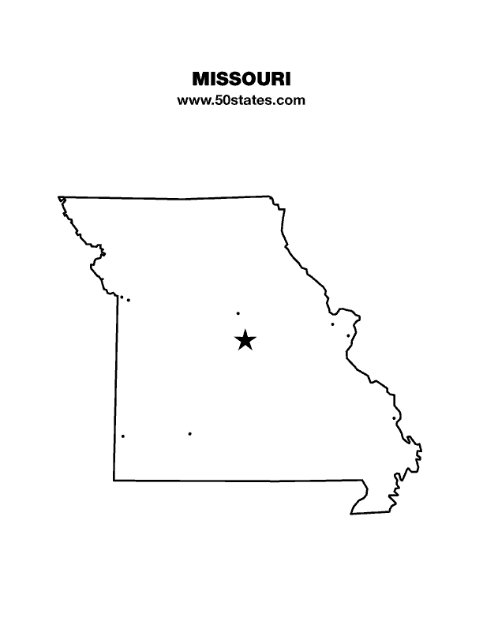
The Blind Missourian
December 2022

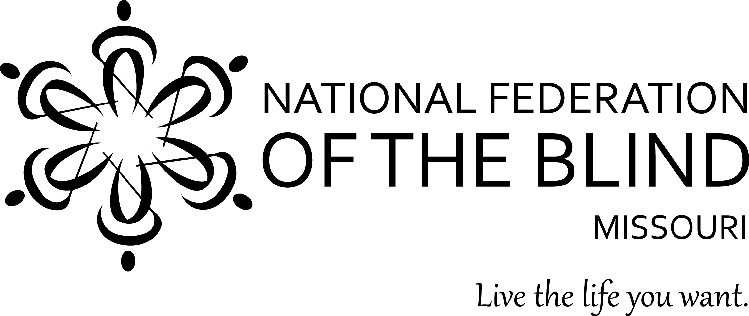

Table of Contents

Voting Rights by Melissa Kane 1

Blind Equality Achievement Month Celebrations
by Stephanie McDowell 1

Celebrating October by Janice Grisham 2

Columbia Chapter by Gary Wunder 3

Kansas City Chapter 2022 Blind Equality
Achievement Month by Daniel Garcia 3

Social Security Benefits For 2023 by Eugene Coulter 5

Chapter Elections by Carol Coulter 7

61st Annual Convention of the National Federation
of the Blind of Missouri 8

NFB Pledge 12

One Minute Message 12

Voting Rights
By Melissa Kane

For many years we have worked to get the legislature to pass a requirement to have accessible ballot marking devices at all polling places during every election. As nonpolitical as this should be, our advocacy has failed to produce any results with the legislature. We have also had meetings with the Secretary of State’s office. These too have produced no results.

After years of advocacy that produced no results, the National Federation of the Blind(NFB) partnered with the Missouri Council of the Blind and with the assistance of the NFB’s national office, a complaint was submitted to the Civil Rights Division of the United States Department of Justice. This complaint was submitted at the end of September of 2021.

Recently there has been action from the Department of Justice. On November 3, I spoke to two US attorneys regarding my voting experiences in Cole County. They intended to conduct monitoring during Election Day in Jefferson City. Unfortunately, County Clerk Steve Korsmeyer refused to allow the Department of Justice officials inside the polling locations. They had to remain outside the polling places and be at least 25 feet away. One doesn’t have to be partisan or political to ask how this can happen in a country in which cities are subordinate to counties, counties to states, and states to the United States of America. Whatever one’s political persuasion, one can’t help being offended by seeing that our rights to have an accessible voting experience is placed second to an argument about whether the federal government has the ability to enforce federal law.

Blind Equality Achievement Month Celebrations
By Stephanie McDowell

The Lewis and Clark chapter celebrated Blind Equality Achievement Month in a variety of ways throughout the month of October. Our goal was not only to bring awareness to the abilities and diversity of blind people, but to encourage other blind people to live the life they want. One of the activities was an information booth at the Italian Festival that took place at Berra Park. Chapter members engaged with festival attendees by providing literature, writing names in Braille, and sharing personal experiences. We also got the St. Louis County Executive and the St. Louis City Mayor to sign a proclamation designating October 15, 2022, as “White Cane Awareness Day”.

The chapter also held a Dine and Donate event at a local Pasta House. Many community members came out to support the Lewis and Clark Chapter, and we were also able to provide them with information about the National Federation of the Blind. Our final activity involved two Lewis and Clark Chapter members. Judy Redlich, a chapter member, has her own weekly radio show called Encounters, and she interviewed fellow chapter member Annette Nowakowski. Annette told her story of getting through school, passing the Illinois state bar exam, and becoming a lawyer. The interview aired on November 1st.

Celebrating October
By Janice Grisham

The Springfield Chapter has been busy celebrating Blind Equality Achievement month. We started the month off on October 1 with Becky Boyer, Hal Boyer, and Janice Grisham attending the state affiliate board meeting in Columbia, Missouri. We had our monthly meeting at our new location, The Station Library on North Kansas in Springfield.
On October 13, in a joint venture with the Springfield Chapter, Mary’s Braille Transcription Services, and The Missouri Council of the Blind, we met with Mayor Ken McClure of Springfield where he signed the White Cane proclamation for October 15. Then on October 15 we had our annual garage sale which was very successful. We finished the month off on October 28 with a track- or- treat at the Springfield Cardinals Hammons Field presented by Mediacom and Springfield Cardinals. We set up a booth along the warning track on the baseball field along with other exhibitors. We dressed in costumes and passed out tons of cheeseballs along with Braille cards and other literature provided by our national office. The Braille cards were a hit. The teenagers even enjoyed helping along with our little ones dressed in their costumes. They helped pass out the cheeseballs and literature. I don’t know what we would’ve done without their help. It was a long and tiring day, but we are definitely looking forward to doing it again next year. It was a blast. We hope everyone else had a successful Blind Equality Achievement Month. Let’s go live the life we want!
Columbia Chapter
By Gary Wunder

The Columbia Chapter celebrated Blind Equality Achievement month by sending out tweets explaining what it was all about. We had the Mayor Pro Tem read and presented a proclamation at our chapter meeting which happened to be on October 15, White Cane Safety Day. Gene, of course, had it immediately saved to the archives. He is very good at preserving our history. Gary Wunder appeared on “Radio Friends with Paul Pepper”. It is a local radio show. He talked about Blind Equality Achievement Month and what the National Federation of the Blind is and what we do.

Kansas City Chapter 2022 Blind Equality Achievement Month
By Daniel Garcia

Remembering history, celebrating achievement, and advancing equality is what we do during October, Blind Equality Achievement Month. It is during October that the National Federation of the Blind puts forth an extra effort in advocating for the rights of the blind and bringing public awareness to dispel myths and misconceptions about the blind. The Kansas City Chapter was active in promoting the goals of Blind Equality Achievement Month during October 2022.

In response to a few email messages I sent to various Kansas City Area Transportation Authority (KCATA) officials, I received a call on October 6, from Lewis Lowry, Chief Transportation Officer for the KCATA, about the inaccessibility of the application form to obtain or renew eligibility for the complementary paratransit service. We agreed that the NFB and the KCATA would work to resolve this issue. I also invited him to a future chapter meeting so we could have a conversation about other topics of interest to blind KCATA passengers. Sadly, he said he would not be able to attend the October 15 chapter meeting which would have been most appropriate since this is White Cane Awareness Day, but he did agree to attend our November meeting.

Two days later on October 8, a few members of our chapter went bowling. The bowling alley staff treated us very well, and as I explained in my thank you letter to them, this was more than just a mere social outing. This event showed the community that blindness does not hold us back from engaging in fun recreational activities. It also provided an opportunity for bonding among chapter members. Though the primary purpose of the NFB is not to be a social organization, it is through social interactions that we strengthen relationships among chapter members; this improves our ability to retain our membership and leads to improved working relationships between chapter members.

It was not until Wednesday, October 12, that we were able to go to city hall to pick up a proclamation that had been signed a few days earlier by Mayor Quinton Lucas declaring October 15, 2022, as White Cane Awareness Day. The credit for this happening goes to Tony Waterhouse-Leal who chairs the chapter Civic Engagement Committee. Below are excerpts from an email message he sent to the committee on October 14.

“On October 12, 2022, The National Federation of the Blind met with city leaders to declare October 15 as White Cane Awareness Day in Kansas City, Missouri. White Cane Awareness Day is an event that is recognized nationwide to celebrate the achievements of blind and low vision individuals and spread awareness of blindness. Both the Kansas City Chapter of the Federation of the Blind, and The Ivanhoe Chapter of the Federation of the Blind were present to commemorate this momentous occasion in Kansas City to recognize the blind and low vision community in Kansas City. We will use this day to commemorate and celebrate achievements of the blind and to bring awareness to blindness related issues across Kansas City. Special thank you to the National Federation of the Blind [Kansas City Chapter] Civic Engagement Committee for helping to plan and establish White Cane Awareness Day in Kansas City Missouri: Julie Dawson, Ben Blagg, Linda Coccovizzo, Cari Ford, and Brent Ford. [Present in this meeting] Tony Waterhouse-Leal, NFB of KC Civic Engagement Committee Chair; Councilman Kevin O'Neill, 1st District-at-Large; Daniel Garcia, NFB of KC President; Ivanhoe Chapter Vice President Courtney Parker; Conrad Parker; and In Spirit, Mayor Quinton Lucas (Cardboard cutout sitting in office chair)”

The Kansas City Chapter holds meetings on the third Saturday of the month. This year, therefore, our October chapter meeting happened on October 15, White Cane Awareness Day. In addition to the usual agenda items that are part and parcel of any regular NFB chapter meeting, we were treated to a reading of the proclamation by Kathy Giffen, a very active member of our chapter.

Two weeks later on October 30, Jeff & Kathy Giffen as well as Tony Waterhouse-Leal participated in a trunk or treat event at the Fraternal Order of the Eagles Aerie Number 47. In addition to giving candy to the young trick-or-treaters, they also handed out NFB brochures and other literature to the accompanying adults. In so doing, they informed the public about our organization and about the important work we do to improve the welfare of the blind.

We are very fortunate to have as a member of the Kansas City chapter our affiliate President, Shelia Wright, who was recently elected to serve on our national board of directors. On October 30, she submitted a guest commentary to the Kansas City Star on the subject of accessible voting for the blind. In this piece she explained how accessible voting ballot marking devices (BMDs) personally benefited her and how these machines make it possible for the blind and people with other disabilities to vote privately and independently. Though the newspaper did not publish this guest commentary until November 4, it was written in October and in the spirit of Blind Equality Achievement Month to inform Kansas City voters about “one of the best kept secrets of our election system.”

In November we not only celebrate the founding of the NFB on November 16, 1940, but we also celebrate Thanksgiving. I am very grateful for the work of our chapter members during Blind Equality Achievement Month and the creation of a national blind people’s movement dedicated to improving life for all blind people.

Social Security Benefits For 2023
By Eugene Coulter

Good news, for the first time in ten years, there will not be an increase in the standard Medicare premium; in fact, it will decrease. Currently the premium is $170.10; in 2023 it will go down to $164.90 or a decrease of $5.20. There will even be a slight decrease in the annual deductible. Also, for those paying for prescription drug coverage, Part D, in most cases the premium will likely decrease.

Supplemental Security Income (SSI) for individuals will increase from $841 to $914, and couples from $1,261 up to $1,371. The resource limit for SSI remains unchanged at $2,000 for a single person and $3,000 for a couple.

Social Security checks will increase by 8.7%. The Substantial Gainful Activity (SGA) income limit for blind recipients will go from $2,260 to $2,460 a month. For non-blind beneficiaries,
the SGA income limit will go from $1,350 to $1,470.
A Trial work period month will be counted for earnings exceeding $1,050 for up to nine months within a five-year period.

The only negative news for most of us is that to earn a quarter of coverage toward being eligible for Disability benefits in 2023, you need to earn $1,640 which is up from $1,510. You will receive credit for four quarters of coverage in 2023 if you earn at least $6,560 regardless of when in the year you earn the income.

If you want to figure your 2023 check amount follow the steps below. Note: due to Social Security rounding rules the amount you calculate maybe a couple of dollars different than what you figure.

- Add your current check amount together with the current Medicare premium of $170.10
- Then multiply that figure by 1.087
- Next, subtract the new Medicare premium of $164.90.
- Finally, discard any cents and you have a reasonable estimate of your new amount.

Here is an example:

- Betty Lou’s 2022 check is $1,201
- Add her Medicare Premium of $170.10 giving you her gross Social Security benefit of 1,371.10
- Multiply $1,371.10 by 1.087 giving you her new gross benefit of $1,490.38
- From 1,490.38 subtract $164.90 giving a result of $1,325.48. Discarding the pennies gives Betty Lou an estimated check of $1,325.00

For those receiving a lesser amount of SSI or those getting Disability who are not yet on Medicare, simply multiply your current check by 1.087 to get your new payment amount.

One final note: whenever a person is eligible for Medicare, they should ALWAYS take out the coverage. Failure to do this can result in penalties later causing your premiums to soar when you really need the coverage.

Chapter Elections
By Carol Coulter

The following National Federation of the Blind of Missouri chapters held elections in November. The Kansas City Chapter reported that their board takes office at the end of their November meeting. Here are the results of those elections. Congratulations to all the elected officers and thank you to all who have served.

Lewis & Clark Chapter:
President, Jenny Carmack
Vice President, Mark Harris
Secretary, Stephanie McDowell
Treasurer, Randy Carmack
Board Member, Aida Talic

Jefferson City Chapter:
President, Melissa Kane
Vice President, Eric Meister
Secretary, Carolyn Patterson
Treasurer, Nina Theroff
Board members, Sue Tussey, Vivian Smith and Pam Nesslehoff

Columbia Chapter:
President, Gary Wunder
Vice President, Gene Coulter
Secretary, Dacia Cole
Treasurer, Carol Coulter
Board member/Historian, Grace Warn

Kansas City Chapter:
Daniel Garcia, President
Linda Coccovizzo, First Vice President
Debbie Eifler, Second Vice President
Sarah Coccovizzo, Secretary
Jeff Giffen, Treasurer
Willa Patterson, First Board Position
Tony Waterhouse-Leal, Second Board Position
Ruby Polk continues to serve as our Immediate Past President

61st Annual Convention of the National Federation of the Blind of Missouri
Hilton St. Louis Airport Hotel
10330 Natural Bridge Road St. Louis. Phone: 314-426-5500
April 13-16, 2023

Pre-register online at www.NFBMO.org
Members of the Lewis and Clark Chapter welcome you to the St. Louis metropolitan area where you can find everything from lakes to rivers, caves and hiking trails, numerous shopping experiences, and any kind of food that you are craving. In addition, St. Louis has more free tourist attractions than anywhere else besides Washington, D.C. In 2021 the St. Louis Society for the Blind published a PDF called “Exploring St. Louis From a Blind Perspective” at https://slsbvi.org/exploring-st-louis/. For foodies neighborhood restaurants abound. Among these is Ted Drewes on historic Route 66. Best of all the 61st annual convention is being held here. We invite you to enjoy this year’s convention with us!

The Hilton Airport Hotel has room rates of $103 a night (plus 17.338% tax). To make reservations, call 314-426-5500 before March 27. The hotel is pet friendly, has a fitness center, EV charging, free Wi-Fi, and free airport transportation. Constellations Lounge is open for dinner and Worlds Away is open for breakfast and lunch with 24-hour room service. Check-in is 3:00 PM and check out is noon.
We have the Frugal Federationist Package again this year for $70 if bought by April 4. This includes convention registration, a banquet ticket, and a Saturday lunch ticket, saving you up to $30. We will also have a planned lunch for Friday and the Prayer Breakfast Sunday. After April 4 the cost for registration and all meals will increase by $5 each. Registration will be open from 8:15 to 8:45 AM and 5:00 PM to 7:00 PM Friday, and 8:00 to 8:25 AM Saturday. Hospitality will be open Friday from 5:00 PM to 10:00 PM.
We will be offering the Kid’s Zone for children in need of supervised care. There is no cost for children who are registered for the convention. See the information on the following pages for details on Kid’s Zone, children’s meal prices, and exhibitor/sponsorships. To donate door prizes, please contact Chair, Charlotte Bellmyer. Her email address is cebellmyer@gmail.com, and those bringing door prizes should drop them off at the registration table.

National Federation of the Blind of Missouri
61st Annual Convention, April 13-16, 2023

Please use one form per residence. Several registrations may be combined on one check if they are sent together. Sorry No refunds unless the event is cancelled.
Registrant Name: ________________________________________________
Second registrant: _________________________________
Street Address: __________________________, Apt.: ________
City: ______________________, State: ____, Zip Code: _________
Phone Number: ______________, Email: _____________________
Select preferred agenda format: __ Braille, ___ Print, ___ Electronic

Select the items or events that you would like to purchase below:
Frugal Federationist Package: prior to April 4, 2023
Number of Packages: ___ at $70.00 Total: $______
*Convention Registration: Preregistration prior to April 4, 2023
Number of registrants: _____at $25.00 Total: $______
*Annual Banquet: ____tickets needed at $40.00 Total: $______
*Friday Luncheon: ____ tickets needed at $20.00 Total: $______
*Saturday Luncheon: ____ tickets needed at $20.00 Total: $______
*Prayer Breakfast: ____ tickets needed at $15.00 Total: $______

Total amount enclosed: $______
*For forms postmarked after April 4, 2023, please add $5 each for registration, and each meal. Add amounts on all forms enclosed and make your check payable to: NFB of Missouri. Please mail to: Carol Coulter, 1504 Furlong Drive, Columbia, MO 65202.

National Federation of the Blind of Missouri Convention
Children’s Registration Form and Kid’s Zone Request
April 15-16, 2023

We will be offering childcare for those children of parents who are registered for the convention in need of supervised care. There is no additional cost for children who are registered for the convention, see the form below to register. Care will be provided during all general sessions and the evening banquet until 9:00 PM. Meals are not provided in the Kid’s Zone, so parents need to make arrangements to feed their children. Important: Parents wanting care for their children must send this request along with payment for registration and meals on or before March 24, 2023. Mail it along with payment to the address below. Note: for children not needing childcare, payments for pre-registration and meals must be received by April 4. Payments can be mailed or made at www.nfbmo.org. Meals and registration purchased after April 4, 2023, will cost an additional $5.00 each.
Name of Parent or Guardian: _____________________
Address: ________________________________________
City, State, Zip: ________________________________
Cell Phone: _______________ Home Phone: ________________
Names and Ages of Children: ________________________________________
__________________________________________________________________Special Concerns: __________________________________________________________________Are the above named children in need of services in the Kid’s Zone? _____
Number of registrants: ___ at $10.00 Total: $______
Annual Banquet: ____ tickets needed at $20.00 Total: $______
Friday Luncheon: ____ tickets needed at $10.00 Total: $______
Saturday Luncheon: ____ tickets needed at $10.00 Total: $______
Prayer Breakfast: ____ tickets needed at $10.00 Total: $______
Total amount enclosed: $______
Mail form and check made payable to NFB of Missouri to: Carol Coulter, Treasurer, 1504 Furlong Drive, Columbia MO 65202.

National Federation of the Blind of Missouri Convention
Sponsorship and Exhibitor Registration April 14, 2023

We are pleased to offer the opportunity for companies and organizations to either exhibit or sponsor our 2023 convention. This year we will be at the Hilton St. Louis Airport Hotel 10330 Natural Bridge Road from April 14-16. Exhibits will be open on Friday, April 14 from 1:00 PM to 9:00 PM. Below is the registration form including information on sponsorships. Forms must be returned by April 4.

Name of Organization: _____________________ Phone: __________________

Contact person: _______________________ Email: ___________________

Address: _____________________________________________

Items exhibiting: __________________ ___________________

Exhibits:
____ $40 for exhibit table only
____ fee waved NFB Chapter or division exhibit

Sponsorships:
____ Bronze $100 includes exhibit table, 25-word informational message in agenda, and a mention on the www.NFBMO.org State Convention Page until April 30, 2023.
____ Silver $250 includes exhibit table, 60-word informational message in agenda, a thank you at opening ceremony and banquet, and a mention on the www.NFBMO.org State Convention Page until April 30, 2023.
____ Gold $500 includes exhibit table, 100-word informational message in agenda, a thank you at opening ceremony and banquet, and a mention on the www.NFBMO.org Home Page and State Convention Page until April 30, 2023.
____Diamond $1,000 same as Gold plus a one-hour showcase Friday morning.
Make checks payable to NFB of Missouri and mail to: Carol Coulter, Treasurer 1504 Furlong Drive, Columbia, MO 65202.

Pledge of the
National Federation of the Blind

I pledge to participate actively in the efforts of the National Federation of the Blind to achieve equality, opportunity, and security for the blind; to support the policies and programs of the Federation; and to abide by its Constitution.

One Minute Message

The National Federation of the Blind knows that blindness is not the characteristic that defines you or your future. Every day we raise the expectations of blind people, because low expectations create obstacles between blind people and our dreams. You can live the life you want; blindness is not what holds you back.

Board of Directors
National Federation of the Blind of Missouri

Officers:
Shelia Wright, President Melissa Kane, First Vice President
Jenny Carmack, Second Vice President Becky Boyer, Recording Secretary
Daniel Garcia, Corresponding Secretary Carol Coulter, Treasurer

Board Members:
Eugene Coulter Dennis Miller Janice Grisham
Amy Wilson Randy Carmack Jeff Giffen Svetlana Ehlers President Emeritus, Gary Wunder

Chapter Presidents
Columbia Chapter, Gary Wunder, 573-874-1774
Jefferson City Chapter, Chris Griggs, 573-418-9284
Springfield Chapter, Janice Grisham, 417-761-0253
Kansas City Chapter, Daniel Garcia, 816-505-5520
Lewis and Clark Chapter, St. Louis, Jenny Carmack, 314-239-9776
Mineral Area Chapter, Farmington, Roger Crome, 573-701-8409
Show Me State Chapter, meets via conference call, Dennis Miller, 660-234-5351
Ivanhoe Chapter, Kansas City, Linda Black-White 816-923-7074

Blind Missourian Editor Carol Coulter
Proofreaders: Shelia Wright, Daniel Garcia and Grace Warn
Read by Elisabeth Coulter

FREE MATTER FOR THE

BLIND AND PHYSICALLY

HANDICAPPED

NFB of Missouri
1504 Furlong Dr.
Columbia, MO 65202

