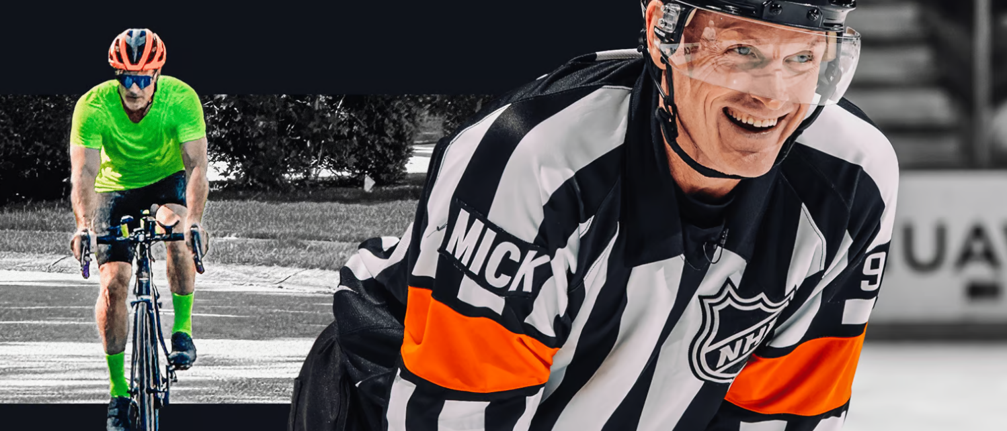

Dan O’Rourke has been an on-ice official for the National Hockey League (NHL) since 1999. After growing up watching his blind father defeat all obstacles in his path, Dan wants to give back to the organization that further empowers blind people to live the lives they want. In partnership with the National Federation of the Blind to raise awareness for braille literacy Dan is riding a bicycle from Santa Monica, California, to Chicago, Illinois, along the famous Route 66.

Route 66 Ride for Braille Literacy

Pit Stop Party

When: Thursday August 31, 2023 from 4:00 pm to 6:00 pm

Where: Kirkwood Public Library

140 E. Jefferson Ave. Kirkwood, MO 63122

We will have games and STEM activities with braille on display, get your name written in braille, enter a raffle to win an official autographed NHL game puck, meet members of the St. Louis Blues Blind Hockey Club and much much more.

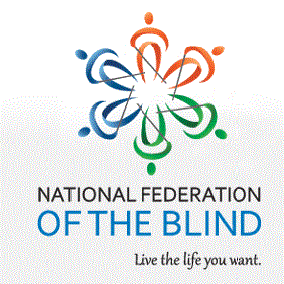For more information: www.nfb.org/route66

*The National Federation of the Blind knows that blindness is not the characteristic that defines you or your future. Every day we raise the expectations of blind people, because low expectations create obstacles between blind people and our dreams. You can live the life you want; blindness is not what holds you back.*